Current Event Project
As we’ve discussed constantly throughout the semester, history happens every day. Looking back on the past makes it easier to see the most important people, issues, and events, but identifying them in their present time requires you to understand the significance of the event as well as why it’s vital to the past, present, and future. For this assignment, you will identify a major current event through two news articles and relate them to the Roaring Twenties.
As you’ll recall from our discussions throughout the unit, the Roaring Twenties were a time of tremendous change, signaled by the end of World War I and defined by the struggle between modernism and tradition. As we discussed in class throughout the unit, the changing roles of women and minorities challenged existing social norms and brought about new forms of expression for disenfranchised groups. The Scopes Trial and Prohibition brought moral values to court, creating opposing arguments on either side. New technologies such as radio and cars connected Americans using new forms of communication and transportation which revolutionized the country forever.
In hindsight, we have been able to look back at these major turning points of the Roaring Twenties, identify clear changes, and measure their impact on the modern era. But nearly a century later, many of these same issues still make the headlines. Women and minorities continue to challenge existing obstacles which stop them from gaining equal income, rights, and freedom of expression. Teaching evolution in schools is still a widely debated topic in education. While Prohibition of alcohol was proven to be ineffective, similar policies continue to be a hot topic of debate in modern medicine. New technologies and innovations appear every day, to the point they are almost taken for granted. For as much as we have progressed in the last hundred years, it is crucial to recognize that many of the core issues of the Roaring Twenties still exist in modern society, as many hold to traditional ideals against the tides of change. By identifying these issues, you will be able to see the type of events that students may be reading about related to our time decades from now.

The Directions
What you’ll need to turn in:
  - Minimum two, typed pages, 12 point font, double spaced, with 1” margins.
  - Minimum of two articles related to a current event from credible sources
  - A five slide Powerpoint presentation with five images OR a poster with five images which must be large enough for the whole class to see.
Three, Typed Pages must contain:
- A summary of both articles, including the main points of the each article.
- Similarities/differences between the two articles.
- Your opinions on the topic.
- How it relates to the Roaring Twenties.
Two articles must be:
- From a credible news source (Times, CNN, BBC, etc.)
- Related to an American issue (while world events are equally important, this is a U.S. History class).
- Be cited in Chicago format at the end of your paper.
- Printed out and attached to your final project.
Presentation must:
- Be accompanied by a Powerpoint or poster with five images and article citations.
- Include the main ideas of each article, the student’s opinion on the topic, and how it relates to the Roaring Twenties.
- Be at least 3 minutes in length, with students making eye contact and speaking loudly enough to be heard by other students.

Things to remember: This project will not be done in class. You will be responsible for researching, writing, and creating the entire project on your own, so plan ahead. For further guidelines, see the attached scoring guide or talk to me so that we can resolve any issues early on. Topics must be approved by the teacher no later than one week before the assignment’s due date. During presentations, students are expected to be respectful to their fellow students. Failure to do so will result in a loss of points toward their own presentation.
Current Event Project Scoring Guide
These are the guidelines and expectations for your current event project. Please refer to them when completing the assignment and feel free to ask any questions in advance of the due date.
Written
Comprehension | Student’s writing displays a thorough knowledge of the subject by convincingly connecting their current event to the Roaring Twenties. | __/20
Articles | Project includes at least two credible, national news sources related to the same topic and explores the similarities and differences between each article. | __/15
Summary | Student’s written summary includes the main points of each article, student’s opinions, and a thorough explanation of the topic. | __/30
Grammar/Punctuation | Student’s writing does not have any grammar or punctuation errors. | __/15
Organization | Student’s project is at least 2 typed pages (12 point font, double spaced), has printed articles attached, and connects the topic to the Roaring Twenties. | __/20

Presentation
Voice/Eye Contact | Student’s speech is loud enough for the rest of the class to hear and the student makes consistent eye contact with others. | __/10
Organization | If digital, the presentation has at least 5 slides with 5 images. If poster, it includes 5 images and is large enough for all students to see. Presentations also contain proper citations for the articles discussed. | __/20
Subject Matter | Student is knowledgeable enough on the topic to thoroughly present their articles and explain how they are important to today as well as how they relate to the Roaring Twenties. | __/10

Total: _______/150 points
Student Sample
To get you started, here is an example of a 100 point paper. Refer to this guideline while completing your project. Note that this paper: summarizes both articles, connects the topic to the Roaring Twenties throughout, and has no grammar or punctuation errors.

The Future of Self-Driving Cars
When the automobile was invented, it was considered to be one of the most revolutionary, technological advances of the modern era. Although we still use cars on a daily basis for multiple things, new innovations have paved the way for self-driving cars to begin appearing on American streets. According to an article in Fortune, Google’s first self-driving car has exceeded expectations by traveling nearly one million, unmanned miles on California streets. In another article from NPR, the author discussed the first self-driving semi-truck built by Daimler, which could change the way we transport goods. While many are skeptical of self-driving cars, rigorous testing and analysis has found that human errors have been the only cause for collision since Google began testing their first, self-driving automobile.
In Fortune, the author discussed how Google has been testing their self-driving car for over six years. During testing, the car has been in several minor accidents, however all were found to be caused by human error. According to the article, “The exact number of accidents isn’t clear. Google acknowledged 11 accidents, but Delphi admitted to 12” (Fortune). This shows that while many people might be nervous about being on the road with a robot driver, the technology and work that has gone into creating self-driving cars is less fallible than the average human, who can become distracted or make mistakes behind the wheel. This is particularly beneficial for cross country truck drivers, who sometimes drive for long spans of time with little to no break for rest. This has led to accidents such as the one which left comedian Tracy Morgan in critical condition after being hit by an eighteen wheeler when the driver fell asleep (LA Times). Daimler has started testing their first self-driving rig, which would allow truckers more time to rest during their long hauls. As the article stated, “Daimler says the Inspiration, the first self-driving truck licensed to roll on public roads — highways and interstates in Nevada — is the future of trucking and may hit the market before autonomous cars” (NPR). Thus, we can see the beginning of a new era in automotive transport, much like people during the Roaring Twenties.
While both articles are extremely interesting, by comparing them, it’s easy to spot some of the similarities and differences in their content and purpose. Although they’re both about self-driving technology, one focused on Google’s personal vehicles, while the other examined Daimler’s mass transit, semi-truck, showing the wide spectrum of growth in self-driving technology. Both authors seem to be in favor of the idea of self-driving cars, citing the benefits of less potential accidents, even though the article states that the self-driving car has been in nearly a dozen accidents. However, because these were caused by human mistakes, it shows how the potential for self-driving cars could stop accidents in the future and save lives. Humans aren’t perfect and neither are computers, yet the potential benefit of a car that doesn’t need a driver could change how we travel, how goods are moved cross country, and how safe we feel behind the wheel of a vehicle. I personally believe that while the current technology still needs to be tested and practiced, the beginnings of a transportation revolution are in the making. By moving this technology toward mass transit systems such as buses, we could also reduce the costs of operating such vehicles, making them cheaper and more available to customers.
Although a freeway full of self-driving cars won’t happen today or tomorrow, the fact that this technology is being professionally tested and fine-tuned shows that the potential for driverless vehicles in the future is very real. In the 1920’s, people could probably not imagine the type of trucks, buses, and cars we have designed and built, much like many people today cannot imagine a road full of cars with no one behind the wheel. As Henry Ford once said, “If I had asked people what they wanted, they would have said a faster horse.” However, technological innovations have turned dreams into realities and as we progress further as a society, there is no doubt that tremendous advances in technology will open new doors for future generations.

Sources:
Levin, Doron. "Google: Humans to Blame for Accidents Involving Self-driving cars." Fortune. May 13, 2015. Accessed May 13, 2015. http://fortune.com/2015/05/13/google-humans-to-blame-for-accidents-involving-self-driving-cars/
Locher, John. "Coming Soon To A Highway Near You: A Semitruck With A Brain." NPR. Accessed May 13, 2015. http://www.npr.org/sections/alltechconsidered/2015/05/10/405598189/coming-soon-to-a-highway-near-you-a-semi-truck-with-a-brain.

Remember: You must print out and attach copies of each article to your project.

Article 1:

Google: Humans to blame for accidents involving self-driving cars
- by
- Doron Levin
May 13, 2015, 8:38 AM EDT
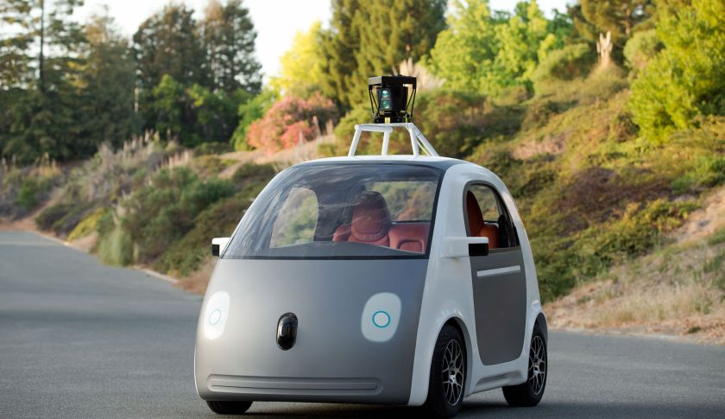

The director of Google’s self-driving project says, “Not once was the self-driving car the cause of the accident.”
Testing of self-driving cars on California roads has resulted in about a dozen minor accidents during the past six years, but humans were to blame for the accidents, Delphi Automotive and Google said.
No one was hurt in the accidents, according to both companies. The accidents came to light after the Associated Press examined state public records covering the companies and the cars, which must be filed in order to test the vehicles on public roads. The filings became mandatory in September.
The exact number of accidents isn’t clear. Google acknowledged 11 accidents, but Delphi admitted to 12.
Chris Urmson, director of Google’s self-driving project, wrote in an Internet post that his company’s 11 accidents involved “light damage, no injuries.” Google has tested its vehicles over 1.7 million, nearly 1 million in self-driving mode.
“Not once was the self-driving car the cause of the accident,” he wrote.
Kristen Kinley, a spokeswoman for Delphi – a maker of automotive parts and components – said in an interview with Fortune that “these are engineering vehicles. You can’t get from A to B – to driverless cars – without a lot of testing. Driverless is still a long way off.”
As digital automotive safety technology improves, engineers are increasingly convinced that computers one day will take over for drivers, creating a transportation system that is far safer than today’s. Cars already can be equipped with sensors that can keep a car in its lane, brake to prevent a rear-end collision and detect pedestrians and bicyclists.
Yet few of the owners of the 250 million or so vehicles registered on U.S. roads have yet experienced even partially autonomous systems. The Boston Consulting Group, in a study released in January, forecasted “partially autonomous vehicles are likely to hit the roads in large numbers by 2017.”
The new technology is bound to worry and bewilder more than a few drivers, which is why Google, Delphi and the automakers are undertaking prolonged, extensive testing under real-world conditions to explore possible pitfalls and demonstrate technological effectiveness – with the goal of overcoming consumer skepticism.
“The potential for safety is enormous,” said Kinley. About 33,000 traffic fatalities were recorded in the U.S. in 2013. Delphi has been testing among its vehicles an Audi SQ5 in Silicon Valley. In October, while the car was stopped at an intersection, a second car jumped a median and collided with it, Kinley said. The car was in manual mode. No one was hurt.
In early April, Delphi’s autonomous Audi drove 3,400 miles from the west coast to New York, 99 percent of the distance without a driver controlling the car. The test was undertaken to demonstrate the vehicle’s capabilities.
“Many people don’t realize how far along some of these technologies are,” said Xavier Mosquet, leader of BCG’s automotive practice in North America, in the January report. BCG predicts that the technology will be “highly attractive to both carmakers and their customers.”
But first the public must be convinced that the computers, sensors and software that control these new machines will do a superior job of keeping it safe and sound.

Article 2:

Coming Soon To A Highway Near You: A Semitruck With A Brain
May 10, 2015 10:06 AM ET
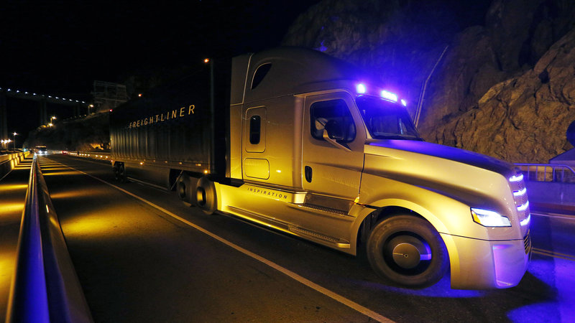

The Daimler Freightliner Inspiration, a self-driving long-haul truck, is seen during an event at the Hoover Dam, May 5, 2015, near Boulder City, Nev.
John Locher/AP
Imagine you're on the highway. You glance into the cab of the 18-wheeler next to you — and there's no driver. That day might be getting closer.
Automaker Daimler unveiled a truck last week that drives itself, called the Freightliner Inspiration. But the truck is not yet entirely autonomous.
"You still have the driver in the driver's seat, ready to take over at all times in case something goes wrong or the system encounters a situation it's not really well prepared for," says Alex Davies, associate editor for Wired, who was at the demonstration and rode in the big rig.
The driver controls the rig on surface roads, but on the highway, engages the autopilot mode. Cameras detect the lane lines to keep the truck headed in the right direction, Davies tells NPR's Rachel Martin.
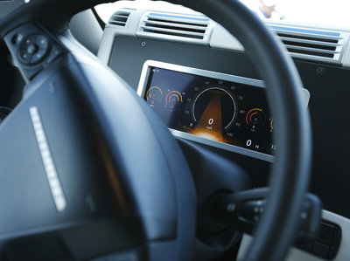i
The Inspiration's dashboard. Although much attention has been paid to self-driving vehicles being developed by Google and others, Daimler believes that automated tractor-trailers will roll on highways before self-driving cars cruise the suburbs.
John Locher/AP
"Then from there on, the truck will stay in its lane, maintain its speed and a safe distance from other vehicles," he says. "But you still need to be in the seat, ready to take over."
And being ready to take over means the driver can't exactly take a nap.
When it's time for the driver to take over — at the correct exit or if bad weather hits — the truck alerts the driver with a beep. If the driver doesn't respond, the truck slows and eventually comes to a complete stop, Davies says.
Daimler says the Inspiration, the first self-driving truck licensed to roll on public roads — highways and interstates in Nevada — is the future of trucking and may hit the market before autonomous cars, according to the Associated Press. Drivers will still be human, but might be called "logistics managers."
"The human brain is still the best computer money can buy," said Daimler Trucks North America LLC CEO Martin Daum.
Davies says no automaker will ever use the term "driverless" for a vehicle, preferring the safer-sounding "autonomous" or, in the case of the Freightliner Inspiration, "piloted."
How it feels in the driver's seat
When you're sitting in the cab of the truck, the freakiest part is watching the wheel turn on its own as the truck stays in its lane on slight curves in the road and even in heavy crosswinds. We were driving around outside Las Vegas, so you get some pretty big crosswinds, and the truck is doing those little things that you do, even without thinking about it, to make sure you're staying right in the center between those lines.
Whether truckers will worry about losing their jobs to a machine
For right now, there's no threat at all to drivers' careers. Daimler will be the first to say so. They say, "No, we still need a driver in the driver's seat, first of all just to handle surface-street driving." This is a system that only works on the highway, and you could take the driver out, but then the truck would just endlessly drive down the highway and would be effectively useless.
That's the real grind of the job: It's just holding the wheel, staying in the lines and following the highway for hours on end. In the middle of the night when you're by yourself, that's where the real tough part of the job is, and if you have a machine that can step in and pick up a lot of the slack for you, I think that would be a welcome change.
On when this technology will be available
Daimler is very cautious to say this is a system it doesn't think will be ready to market for about a decade. That said, this is happening. This has already been happening for about 20 years, and you have all kinds of building-block systems that are leading us toward autonomy.

