Guided Notes: The Rise of Advertising
While following along with the lecture, use this handout to answer the questions from the presentation on a separate sheet of paper.
Times Square Photos: What similarities and differences do you see between these two pictures?
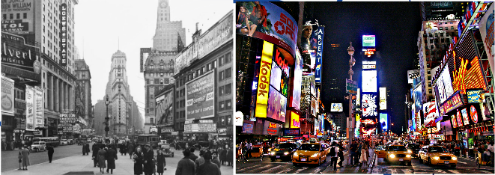
Similarities  1.  2. | Differences  3.  4.

Key Vocabulary:
5. Who or what is a consumer?

6. What is a brand?

7. How do advertisements sell a product or brand to consumers?

Purpose, Appeal, and Audience:
8. List at least 3 “purposes” for advertising:

9. List 3 different “appeals” which advertisements make:

10. Check Yourself: Ford Advertisement
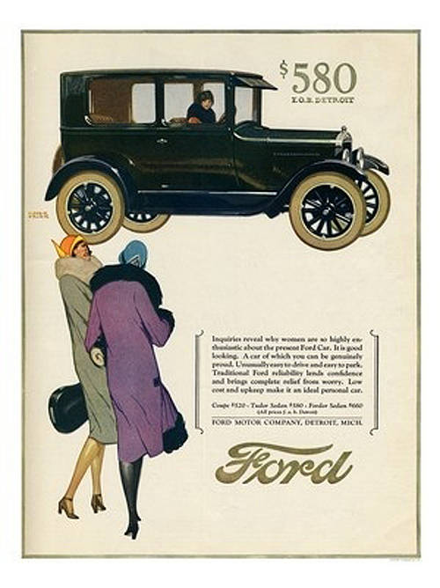
The ad says: “Inquiries reveal why women are so highly enthusiastic about the personal Ford Car. It is good looking. A car of which you can be genuinely proud. Unusually easy to drive and easy to park. Traditional Ford reliability lends confidence and brings relief from worry. Low cost and upkeep make it an ideal personal car.”
What is this advertisement’s purpose(s)?

What appeal(s) does the advertisement use?
11. Based on the appeal(s) and purpose(s) you identified, who do you think is the intended audience for this ad?

12. Practice Makes Perfect: Coca-Cola Ad
What is this ad's purpose?
What appeal does it make?
Who is the ad's audience?
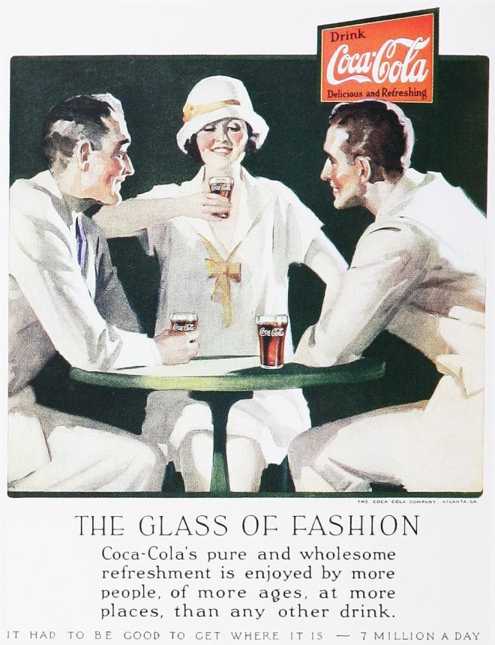
The ad says: “The Glass of Fashion: Coca-Cola’s pure and wholesome refreshment is enjoyed by more people of more ages at more places than any other drink.-It had to be good to get where it is – 7 million a day.
13. On average, how many advertisements are you exposed to each day?

14. What are some of the methods advertisers use today that were not available during the 1920’s?

15. Old Spice ad: Name the purpose, appeal, and audience of the clip

16. Ford ad: 1924 vs. 2015: List similarities and differences of purpose, appeal, or audience between these ads
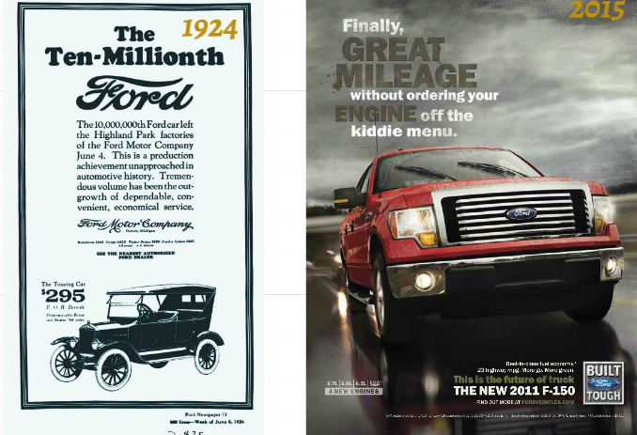
Best in class fuel economy. 23 highway miles per gallon. More go. More green.
Similarities | Differences

Class Discussion Critical Thinking Questions:
Has the purpose of advertising changed since the 1920s?
Are the appeals used in advertisements in during the 1920's the same as today?
How has the audience for advertisements changed?

