Prohibition “Dinner Party”
Use this paper as a guideline for the day’s assignment. Answer all questions on a separate sheet of paper

Journal: Look at the political cartoon below and then answer the questions.
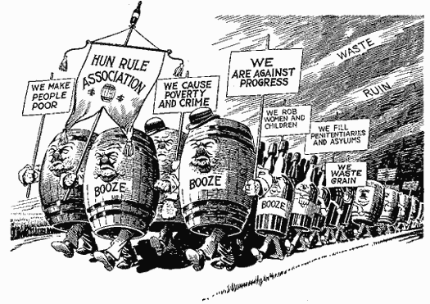
- What do you see in the picture?
- How do you think the illustrator feels about Prohibition?
- Do you agree with the illustrator’s point of view? Why or why not?

When instructed, you will use the card I’ve given you to find your group and assigned role. If you forget the instructions or where you’re supposed to go, reference the detailed instructions below.
“Dinner Party” Discussion: If your card has an A, you are on the North side of the room. If your card has a B, you are on the South side of the room. Go to the pocket on the wall on your side and retrieve the bio that corresponds to your number. (If you are A1, you are on the North side with the paper marked 1). A1-4 , A5-8, A9-12, amd A13-16 will be the North side groups. B1-4, B5-8. B9-12, and B13-16 will be the South side groups.
Once you have your bio, find your group. You will start by completing these questions by yourself:
- What is your person’s name and historical significance?
- What was this person’s role leading up to, during, or after the Prohibition era?
- Did their beliefs about temperance or Prohibition change over time? If so, how?
- How is this person similar to you? How is he or she different?
Starting with the lowest number in your group to the highest, you will each take turns describing who your assigned role is and how they influenced the Prohibition era.
You must also develop at least one question for someone else in your group related to their assigned role. Write the question you came up with on your own paper.
When the buzzer goes off, you will get up from your group and begin discussions with other members of your dinner party (If you’re an A, you are only discussing with other A’s). Without telling each other the names of your assigned roles, discuss your feelings about Prohibition and try to find a new group of 4 who share similar views.

Before you leave class, complete an exit card responding to the following questions:
- Who was your assigned character?
- How did they influence the Prohibition era?
- Was their impact on Prohibition positive or negative?

