Journal:
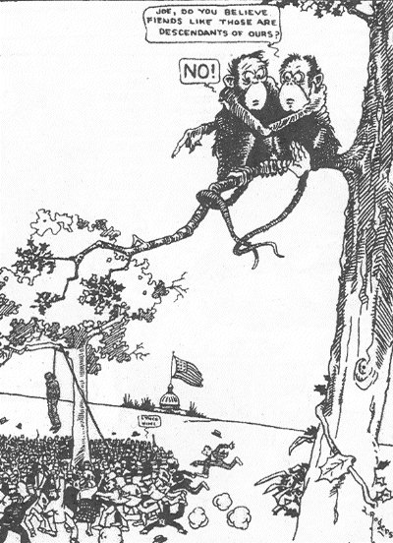
- What do you see in this image?

- Why do the monkeys claim they’re not related to humans?

- What issues do you think the cartoon is discussing?

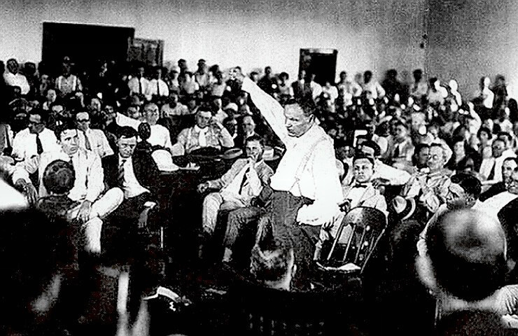

The Scopes “Monkey” Trial
You will be assigned one of four roles: Clarence Darrow, William Jennings Bryan, The Court (judge), and Stewart/Malone/policeman/foreman
This is an actual transcript of the court proceedings during the Scopes Trial. Read along with your group and read aloud for your assigned role during the trial. While reading, consider the arguments which Bryan and Darrow present, pausing as a group to fill out the graphic organizer.
(Note: When it says Q or A, the person speaking is referred to beforehand. If you get lost, go back until the last name you see and read down.)

[Examination of W.J. Bryan by Clarence Darrow, of counsel for the defense: ]
Q--You have given considerable study to the Bible, haven't you, Mr. Bryan?
A--Yes, sir, I have tried to.
Q--Then you have made a general study of it?
A--Yes, I have; I have studied the Bible for about fifty years, or sometime more than that, but, of course, I have studied it more as I have become older than when I was but a boy.
Q--You claim that everything in the Bible should be literally interpreted?
A--I believe everything in the Bible should be accepted as it is given there: some of the Bible is given illustratively. For instance: "Ye are the salt of the earth." I would not insist that man was actually salt, or that he had flesh of salt, but it is used in the sense of salt as saving God's people.
Q--But when you read that Jonah swallowed the whale--or that the whale swallowed Jonah-- excuse me please--how do you literally interpret that?
A--When I read that a big fish swallowed Jonah--it does not say whale.
Q--That is my recollection of it. A big fish, and I believe it, and I believe in a God who can make a whale and can make a man and make both what He pleases.
Q--Now, you say, the big fish swallowed Jonah, and he there remained how long--three days-- and then he spewed him upon the land. You believe that the big fish was made to swallow Jonah?
A--I am not prepared to say that; the Bible merely says it was done.
Q--You don't know whether it was the ordinary run of fish, or made for that purpose?
A--You may guess; you evolutionists guess.....
Q--You are not prepared to say whether that fish was made especially to swallow a man or not?
A--The Bible doesn't say, so I am not prepared to say.
Q--But do you believe He made them--that He made such a fish and that it was big enough to swallow Jonah?
A--Yes, sir. Let me add: One miracle is just as easy to believe as another
Q--Just as hard?
A--It is hard to believe for you, but easy for me. A miracle is a thing performed beyond what man can perform. When you get within the realm of miracles; and it is just as easy to believe the miracle of Jonah as any other miracle in the Bible.
Q--Perfectly easy to believe that Jonah swallowed the whale?
A--If the Bible said so; the Bible doesn't make as extreme statements as evolutionists do....
Q--The Bible says Joshua commanded the sun to stand still for the purpose of lengthening the day, doesn't it, and you believe it.
A--I do.
Q--Do you believe at that time the entire sun went around the earth?
A--No, I believe that the earth goes around the sun.
Q--Do you believe that the men who wrote it thought that the day could be lengthened or that the sun could be stopped?
A--I don't know what they thought.
Q--You don't know?
A--I think they wrote the fact without expressing their own thoughts.
Q--Have you an opinion as to whether or not the men who wrote that thought
Gen. Stewart--I want to object, your honor; it has gone beyond the pale of any issue that could possibly be injected into this lawsuit, expect by imagination. I do not think the defendant has a right to conduct the examination any further and I ask your honor to exclude it.
The Witness--It seems to me it would be too exacting to confine the defense to the facts; if they are not allowed to get away from the facts, what have they to deal with?
The Court--Mr. Bryan is willing to be examined. Go ahead.
Mr. Darrow--I read that years ago. Can you answer my question directly? If the day was lengthened by stopping either the earth or the sun, it must have been the earth?
A--Well, I should say so.
Q-- Now, Mr. Bryan, have you ever pondered what would have happened to the earth if it had stood still?
A--No.
Q--You have not?
A-- No; the God I believe in could have taken care of that, Mr. Darrow.
Q-- I see. Have you ever pondered what would naturally happen to the earth if it stood still suddenly?
A-- No.
Q--Don't you know it would have been converted into molten mass of matter?
A--You testify to that when you get on the stand, I will give you a chance.
Q--Don't you believe it?
A--I would want to hear expert testimony on that.
Q--You have never investigated that subject?
A--I don't think I have ever had the question asked.
Q--Or ever thought of it?
A--I have been too busy on thinks that I thought were of more importance than that.
Q--You believe the story of the flood to be a literal interpretation?
A--Yes, sir.
Q--When was that Flood?
A--I would not attempt to fix the date. The date is fixed, as suggested this morning.
Q--About 4004 B.C.?
A--That has been the estimate of a man that is accepted today. I would not say it is accurate.
Q--That estimate is printed in the Bible?
A--Everybody knows, at least, I think most of the people know, that was the estimate given.
Q--But what do you think that the Bible, itself says? Don't you know how it was arrived at?
A--I never made a calculation.
Q--A calculation from what?
A--I could not say.
Q--From the generations of man?
A--I would not want to say that.
Q--What do you think?
A--I do not think about things I don't think about.
Q--Do you think about things you do think about?
A--Well, sometimes.
(Laughter in the courtyard.)
Policeman--Let us have order....
Stewart--Your honor, he is perfectly able to take care of this, but we are attaining no evidence. This is not competent evidence.
Witness--These gentlemen have not had much chance--they did not come here to try this case. They came here to try revealed religion. I am here to defend it and they can ask me any question they please.
The Court--All right.
(Applause from the court yard.)
Darrow--Great applause from the bleachers.
Witness--From those whom you call "Yokels."
Darrow--I have never called them yokels.
Witness--That is the ignorance of Tennessee, the bigotry.
Darrow--You mean who are applauding you? (Applause.)
Witness--Those are the people whom you insult.
Darrow--You insult every man of science and learning in the world because he does believe in your fool religion.
The Court--I will not stand for that.
Darrow--For what he is doing?
The Court--I am talking to both of you....
Q--Wait until you get to me. Do you know anything about how many people there were in Egypt 3,500 years ago, or how many people there were in China 5,000 years ago?
A--No.
Q--Have you ever tried to find out?
A--No, sir. You are the first man I ever heard of who has been in interested in it. (Laughter.)
Q--Mr. Bryan, am I the first man you ever heard of who has been interested in the age of human societies and primitive man?
A--You are the first man I ever heard speak of the number of people at those different periods.
Q--Where have you lived all your life?
A--Not near you. (Laughter and applause.)
Q--Nor near anybody of learning?
A--Oh, don't assume you know it all.
Q--Do you know there are thousands of books in our libraries on all those subjects I have been asking you about?
A--I couldn't say, but I will take your word for it....
Q--Have you any idea how old the earth is?
A--No.
Q--The Book you have introduced in evidence tells you, doesn't it?
A--I don't think it does, Mr. Arrow.
Q--Let's see whether it does; is this the one?
A--That is the one, I think.
Q--It says B.C. 4004?
A--That is Bishop Usher's calculation.
Q--That is printed in the Bible you introduced?
A--Yes, sir....
Q--Would you say that the earth was only 4,000 years old?
A--Oh, no; I think it is much older than that.
Q--How much?
A--I couldn't say.
Q--Do you say whether the Bible itself says it is older than that?
A--I don't think it is older or not.
Q--Do you think the earth was made in six days?
A--Not six days of twenty-four hours.
Q--Doesn't it say so?
A--No, sir....
The Court--Are you about through, Mr. Darrow?
Darrow--I want to ask a few more questions about the creation.
The Court--I know. We are going to adjourn when Mr. Bryan comes off the stand for the day. Be very brief, Mr. Darrow. Of course, I believe I will make myself clearer. Of course, it is incompetent testimony before the
jury. The only reason I am allowing this to go in at all is that they may have it in the appellate court as showing what the affidavit would be.
Bryan--The reason I am answering is not for the benefit of the superior court. It is to keep these gentlemen from saying I was afraid to meet them and let them question me, and I want the Christian world to know that any atheist, agnostic, unbeliever, can question me anytime as to my belief in God, and I will answer him.
Darrow--I want to take an exception to this conduct of this witness. He may be very popular down here in the hills....
Bryan--Your honor, they have not asked a question legally and the only reason they have asked any question is for the purpose, as the question about Jonah was asked, for a chance to give this agnostic an opportunity to criticize a believer in the world of God; and I answered the question in order to shut his mouth so that he cannot go out and tell his atheistic friends that I would not answer his questions. That is the only reason, no more reason in the world.
Malone--Your honor on this very subject, I would like to say that I would have asked Mr. Bryan--and I consider myself as good a Christian as he is--every question that Mr. Darrow has asked him for the purpose of bring out whether or not there is to be taken in this court a literal interpretation of the Bible, or whether, obviously, as these questions indicate, if a general and literal construction cannot be put upon the parts of the Bible which have been covered by Mr. Darrow's questions. I hope for the last time no further attempt will be made by counsel on the other side of the case, or Mr. Bryan, to say the defense is concerned at all with Mr. Darrow's particular religious views or lack of religious views. We are here as lawyers with the same right to our views. I have the same right to mine as a Christian as Mr. Bryan has to his, and we do not intend to have this case charged by Mr. Darrow's agnosticism or Mr. Bryan's brand of Christianity. (A great applause.)
Mr. Darrow:
Q--Mr. Bryan, do you believe that the first woman was Eve?
A--Yes.
Q--Do you believe she was literally made out of Adams's rib?
A--I do.
Q--Did you ever discover where Cain got his wife?
A--No, sir; I leave the agnostics to hunt for her.
Q--You have never found out?
A--I have never tried to find
Q--You have never tried to find?
A--No.
Q--The Bible says he got one, doesn't it? Were there other people on the earth at that time?
A--I cannot say.
Q--You cannot say. Did that ever enter your consideration?
A--Never bothered me.
Q--There were no others recorded, but Cain got a wife.
A--That is what the Bible says.
Q--Where she came from you do not know. All right. Does the statement, "The morning and the evening were the first day," and "The morning and the evening were the second day," mean anything to you?
A-- I do not think it necessarily means a twenty-four-hour day.
Q--You do not?
A--No.
Q--What do you consider it to be?
A--I have not attempted to explain it. If you will take the second chapter--let me have the book. (Examining Bible.) The fourth verse of the second chapter says: "These are the generations of the heavens and of the earth, when they were created in the day that the Lord God made the earth and the heavens," the word "day" there in the very next chapter is used to describe a period. I do not see that there is any necessity for construing the words, "the evening and the morning," as meaning necessarily a twenty-four-hour day, "in the day when the Lord made the heaven and the earth."
Q--Then, when the Bible said, for instance, "and God called the firmament heaven. And the evening and the morning were the second day," that does not necessarily mean twenty-four hours?
A--I do not think it necessarily does.
Q--Do you think it does or does not?
A--I know a great many think so.
Q--What do you think?
A--I do not think it does.
Q--You think those were not literal days?
A--I do not think they were twenty-four-hour days.
Q--What do you think about it?
A--That is my opinion--I do not know that my opinion is better on that subject than those who think it does.
Q--You do not think that ?
A--No. But I think it would be just as easy for the kind of God we believe in to make the earth in six days as in six years or in 6,000,000 years or in 600,000,000 years. I do not think it important whether we believe one or the other.
Q--Do you think those were literal days?
A--My impression is they were periods, but I would not attempt to argue as against anybody who wanted to believe in literal days.
Q--I will read it to you from the Bible: "And the Lord God said unto the serpent, because thou hast done this, thou art cursed above all cattle, and above every beast of the field; upon thy belly shalt thou go and dust shalt thou eat all the days of thy life." Do you think that is why the serpent is compelled to crawl upon its belly?
A--I believe that.
Q--Have you any idea how the snake went before that time?
A--No, sir.
Q--Do you know whether he walked on his tail or not?
A--No, sir. I have no way to know. (Laughter in audience).
Q--Now, you refer to the cloud that was put in heaven after the flood, the rainbow. Do you believe in that?
A--Read it.
Q--All right, Mr. Bryan, I will read it for you.
Bryan--Your Honor, I think I can shorten this testimony. The only purpose Mr.
Darrow has is to slur at the Bible, but I will answer his question. I will answer it all at once, and I have no objection in the world, I want the world to know that this man, who does not believe in a God, is trying to use a court in Tennesseee--
Darrow--I object to that.
Bryan--(Continuing) to slur at it, and while it will require time, I am willing to take it.
Darrow--I object to your statement. I am exempting you on your fool ideas that no intelligent Christian on earth believes.
The Court--Court is adjourned until 9 o'clock tomorrow morning.
[Verdict and sentencing]
Court--Mr. Foreman, will you tell us whether you have agreed on a verdict?
Foreman--Yes, sir, we have your honor.
Court--What do you find?
Foreman--We have found for the state, found the defendant guilty.
Court--Did you fix the fine?
Foreman--No, sir.
Court--You leave it to the court?
Foreman--Leave it to the court.
Court--Mr. Scopes, will you come around here, please, sir.
(The defendant presents himself before the court.)
Court--Mr. Scopes, the jury has found you guilty under this indictment, charging you with having taught in the schools of Rhea county, in violation of what is commonly known as the anti- evolution statute, which makes it unlawful for any teacher to teach in any of the public schools of the state, supported in whole or in part by the public school funds of the state, any theory that denies the story of the divine creation of man, and teach instead thereof that man has descended from a lower order of animals. The jury have found you guilty. The statute make this an offense punishable by fine of not less than $100 nor more than $500. The court now fixes your fine at $100, and imposes that fine upon you.
Court--Oh-Have you anything to say, Mr. Scopes, as to why the court should not impose punishment upon you?
Defendant J. T. Scopes-- Your honor, I feel that I have been convicted of violating an unjust statute. I will continue in the future, as I have in the past, to oppose this law in any way I can. Any other action would be in violation of my ideal of academic freedom-that is, to teach the truth as guaranteed in our constitution of personal and religious freedom. I think the fine is unjust.
Scopes “Monkey” Trial Graphic Organizer

Arguments presented by William Jennings Bryan | Arguments presented by Clarence Darrow

How effective were Bryan and Darrow in making their points for and against evolution?

What is your opinion on teaching evolution in schools?

Do you think teaching evolution will always be controversial? Why or why not?

